NAME: K Yamini
REG NO: 192572181

Write a Python program to implement Decision Tree.
Aim:
To implement a Decision Tree algorithm to classify data based on given features.
Algorithm:
- Import required libraries.
- Prepare dataset (features and labels).
- Split data into training and testing sets.
- Create Decision Tree model.
- Train the model using training data.
- Predict output using test data.
- Compare predicted output with actual output.
- Display accuracy and results.
Python Code:
# Simple Decision Tree (Manual)
# Dataset
# Weather: Sunny=0, Rainy=1
# Temp: Cold=0, Hot=1
def decision_tree(weather, temp):
print("# Checking Weather condition")
if weather == 0: # Sunny
print("# Weather is Sunny")
if temp == 1:
print("# Temperature is Hot")
return "Play"
else:
print("# Temperature is Cold")
return "Don't Play"
else: # Rainy
print("# Weather is Rainy")
if temp == 1:
print("# Temperature is Hot")
return "Play"
else:
print("# Temperature is Cold")
return "Don't Play"
# Input
weather = 0 # Sunny
temp = 1 # Hot
print("Input: Sunny, Hot")
result = decision_tree(weather, temp)
print("\nPrediction:", result)
print("# Decision Tree executed successfully")
Input:
Training Data:
Sunny Hot → Play
Sunny Cold → Don't Play
Rainy Hot → Play
Rainy Cold → Don't Play
Test Input:
Sunny Hot
Output :
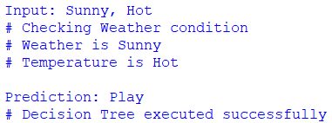
Result:
The Decision Tree algorithm is successfully implemented and used to classify input data based on given features.

